**Function Generator Using Operational Amplifier**

A REPORT

on

B. Tech 4th semester Mini Project-I (EE2191)

BY

| **Group No.** | **Sl. No.** | **Name in alphabetical order with enrolment number** | **Signature with date** |
| --- | --- | --- | --- |
|  | **1.** | **Aditi Mondal,**  **2022EEB004** |  |
|  | **2.** | **Harsh Singh,**  **2022EEB003** |  |
|  | **3.** | **Rupsha Barman, 2022EEB005** |  |
|  | **4.** | **Shalini Bhattacharya, 2022EEB102** |  |

Forwarded and countersigned by: Approved by:

–----------------------------------- ----------------------------------

Joint Convener, DUGC Head of the Department Department of Electrical Department of Electrical Engineering Engineering



DEPARTMENT OF ELECTRICAL ENGINEERING

INDIAN INSTITUTE OF ENGINEERING SCIENCE AND TECHNOLOGY, SHIBPUR

**April 2024**

**DECLARATION BY THE CANDIDATES**

We certify that to the best of my knowledge

1. The work contained in the report has been done by ourselves.
2. We have conformed to the norms and guidelines given in the Ethical Code of Conduct of the Institute.
3. Whenever we have used materials (data, theoretical analysis and text) from other sources, we have given due credit to them by citing them in the text of the report and giving their details in the references.
4. Whenever we have quoted written materials from other sources, we have put them under quotation marks and given due credit to the sources by citing them and giving details in the references.

| SL No. | Name | Examination Roll No. | Signature |
| --- | --- | --- | --- |
| 1 | Aditi Mondal | 2022EEB004 |  |
| 2 | Harsh Singh | 2022EEB003 |  |
| 3 | Rupsha Barman | 2022EEB005 |  |
| 4 | Shalini Bhattacharya | 2022EEB102 |  |
| 5 |  |  |  |
| 6 |  |  |  |

Date:

Place:

**Indian Institute of Engineering Science and Technology, Shibpur**

**Howrah - 711103, West Bengal**



**CERTIFICATE OF APPROVAL**

We hereby approve the B. Tech 4th semester mini project-I report entitled, **‘Function Generator using Operational Amplifier**’ prepared by  **Harsh Singh(2022EEB003), Aditi Mondal(2022EEB004), Rupsha Barman(2022EEB005), Shalini Bhattacharya(2022EEB102)** in partial fulfilment of the requirements for the fourth semester Bachelor of Technology curriculum in Electrical Engineering.

Date........................................

(BOARD OF EXAMINERS)

1. ……………………………..
2. ……………………………..
3. ……………………………..
4. ……………………………..
5. …………………………….
6. ……………………………..

**ACKNOWLEDGEMENT**

We extend our heartfelt gratitude to Professor Paromita Chattopadhyay, whose unwavering guidance and mentorship have been instrumental in shaping the trajectory of our Function Generator using Operational Amplifier project. Her expertise and encouragement have been invaluable throughout this journey.

We would also like to express our sincere thanks to Professor Anindita Sengupta, the Head of the Department of Electrical Engineering, for her gracious support and for granting us access to the essential laboratory equipment. Her belief in our project has been pivotal in the successful realisation of our project.

We would especially like to thank all our professors who have generously shared their knowledge and expertise with us. Their dedication to teaching and willingness to impart the necessary skills and insights have been crucial in equipping us with the tools needed to bring this project to fruition.

We are truly grateful for the enriching learning experience and the opportunity to contribute to the field of electrical engineering under their guidance.

**ABSTRACT**

This technical report presents the design and development of a function generator using operational amplifiers (op-amps). The implementation phase involved a circuit simulation, prototyping on a breadboard, and finally testing and validating waveform outputs using the Oscilloscope we had developed as our mini project in the 3rd semester.

Function generators are essential tools in electronics laboratories, providing precise and versatile waveform generation for testing and experimentation purposes. In this work, we explore the principles of op amp-based function generation. Our function generator can produce three kinds of waveforms, namely sine wave, square wave and triangle wave. Through simulation and testing, we evaluated the outputs of the function generator, validating its effectiveness as an extension of the simulated oscilloscope project. The integration of both systems provides a comprehensive platform for electronic signal manipulation and analysis.

**CONTENTS PAGE NO.**

**LIST OF SYMBOLS vii**

**LIST OF FIGURES viii**

**LIST OF TABLES ix**

**CHAPTER ONE 1**

Introduction

**CHAPTER TWO 2**

* What is a function generator?
* What are the different types of function generators?
* What are the applications of function generators?
* What is the difference between signal generators and function

generators?

**CHAPTER THREE 4**

* Working of the model with schematic diagrams and detailed explanation
* Output waveforms

**CHAPTER FOUR 9**

Data Sheet of UA741CP

Specifications of the components used

**CHAPTER FIVE**

Scope for Future Work and Conclusion **13**

**REFERENCES 14**

**List of symbols**

The following symbols have been used in this project:

* The IC-741

1. Pin 1- Offset Null 1
2. Pin 2- Inverting input terminal
3. Pin 3- Non- inverting input terminal
4. Pin 4- (-Vee), the negative terminal of the supply voltage
5. Pin 5- Offset Null 2
6. Pin 6- Output pin
7. Pin 7- (+Vcc), the positive terminal of the supply voltage
8. Pin 8- No connect pin

* V : voltage
* R : for resistors
* C : capacitors
* U : UA741CP
* +Vcc : the positive terminal of the supply voltage to the op-amps
* -Vee : the negative terminal of the supply voltage to the op-amps

**List of Figures**

The following figures have been used in the report for a schematic visual depiction of circuits

* Fig. 3.1 - Schematic of the function generator circuit
* Fig. 3.2- Pin out diagram of UA741CP IC
* Fig. 3.3- Power Source for the op-amps
* Fig. 3.2.1- Square wave produced by our function generator
* Fig. 3.2.2- Triangle wave produced by our function generator
* Fig. 3.2.3- Sine wave produced by our function generator
* Fig. 3.2.4- All the output waveforms produced by the function generator, together

**List of Tables**

* **Table 1**: Absolute Maximum Ratings of UA741C
* **Table 2**: Switching Characteristics of UA741C
* **Table 3**: Electrical Characteristics of UA741C
* **Table 4**: Typical Characteristics of UA741C

**CHAPTER ONE**

Introduction

Function generators play a pivotal role in modern electronics laboratories, serving as indispensable tools for generating a diverse range of electrical waveforms essential for testing, characterisation, and experimentation. This report presents the design, implementation, and evaluation of a simple function generator developed using operational amplifiers.

This report outlines the theoretical foundation underlining the design of op amp-based function generators, encompassing concepts such as signal conditioning, waveform synthesis, and frequency modulation techniques. Through detailed circuit analysis, simulation, and prototyping, the methodology employed in realising the function generator architecture is elaborated on, highlighting key design and implementation aspects.

This report aims to contribute to the body of knowledge surrounding function generator design methodologies, particularly focusing on the utilisation of op amps as a versatile building block.

**CHAPTER TWO**

Introduction to a Function Generator:

* What is a function generator?

Simply put, a function Generator is an instrument that can generate common waveforms like triangle wave, sine wave, cosine wave, square wave etc., It can also change the amplitude and frequency characteristics of the produced waveform.

* What are the different types of function generators?

Function generators can be broadly classified into two types:

1. Analog function generators

2. Digital function generators

Analog circuits form the basis of analog-type function generators. Because of their simplicity and ease of use, these function generators are still in use. On the other hand, digital function generators create waveforms by using digital signal processing methods. This implies that they can provide a greater range of waveform kinds and are more precise. Accuracy is higher in the case of digital function generators. Greater versatility is typically available with digital function generators since they provide more possibilities in terms of waveform kinds and modulation algorithms.

* What are the applications of a function generator?

1. Research and Development: When creating and evaluating electrical devices, function generators are frequently utilised in R&D labs.
2. Education: In academic institutions, they are also an essential instrument for teaching electronics and electrical engineering principles.
3. Function generators are utilised in production facilities for the testing and quality control of electrical devices.
4. Repair and Maintenance: To troubleshoot and repair electrical devices, service centres employ function generators.

* What is the difference between function generators and signal generators?

Signal generators only generate a Sine wave, have limited Frequency stability, no capability of phase looking with the external source, and frequency is controlled by frequency range controller. On the other hand, function Generators generate various waveforms like sine, square, sawtooth, triangular. Also, has high-Frequency Stability, capacity to look into external sources.

**CHAPTER THREE**

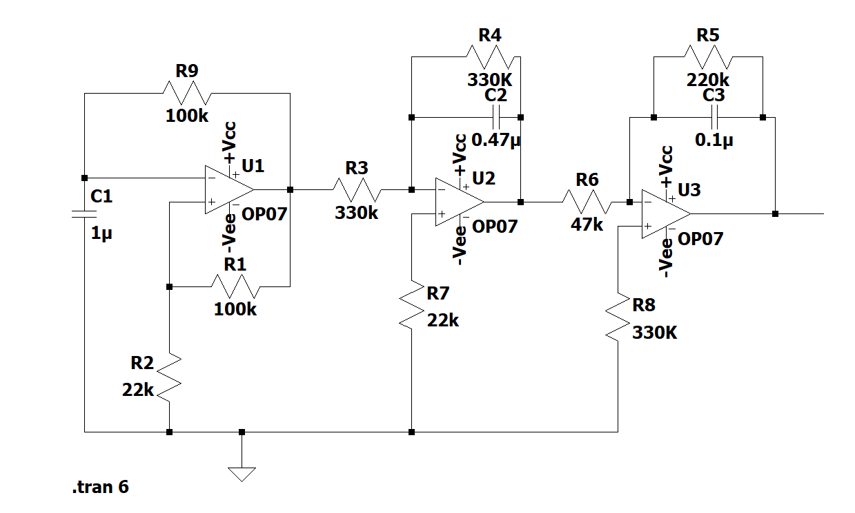

Schematic of the Function Generator Fig. 3.1

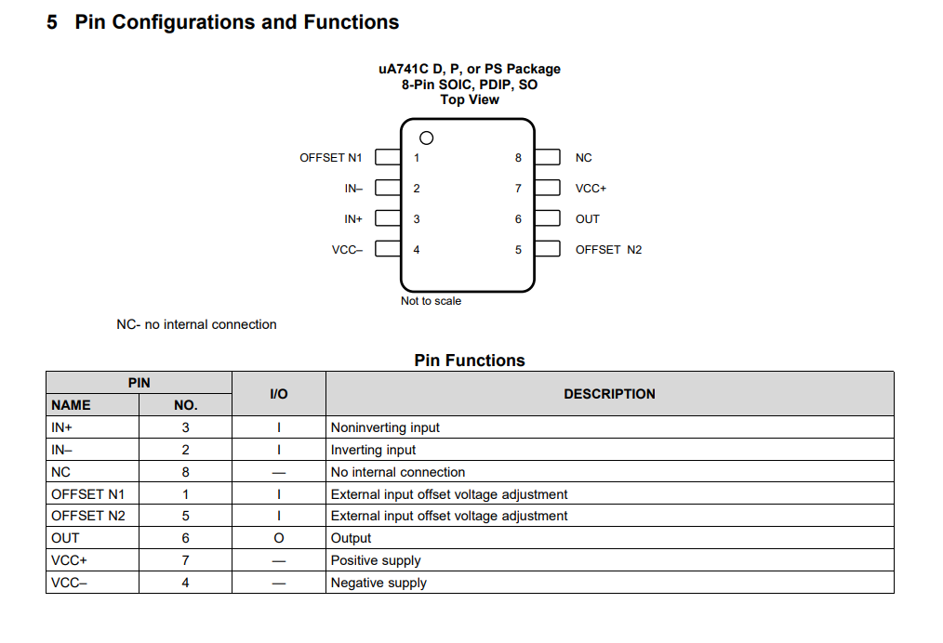

Pin Out Diagram of UA741 IC Fig 3.2

Three UA741CP ICs have been used here. The first op-amp, U1 has been connected as an astable multivibrator. Resistor R9 is the feedback resistor while the capacitor C1 is grounded. Resistor R1 is the positive feedback resistor and resistor R2 is again grounded. The output of U1 is a square wave.

The next op-amp U2 is wired as an integrator. R4 is the feedback resistor and C2 is the integrating capacitor. The non-inverting input pin is grounded through the resistor R7. The square wave output of U1 is applied as input to the inverting input pin through R3 which is the input resistance of U2. Since a square wave gives a triangle waveform on integration, U2 will produce a triangular waveform as its output, with a 90 degree phase shift with respect to the square waveform.

U3 forms another integrator, where R5 is its feedback resistor and C3 is the integrating capacitor. R6 is the input resistance. Non inverting input of U2 grounded using the resistor R8. The triangle wave output of U2 is applied as input to the inverting input pin through R6. The output is a sine wave, in phase with the square wave.

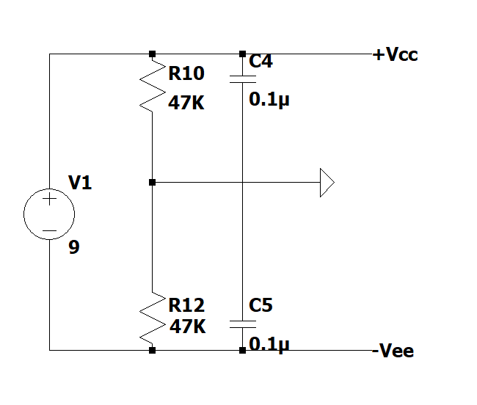

Schematic of the Power Source Circuit Fig.3.3

The UA741 IC requires a +Vcc and a -Vee supply. Using a battery would have only given a +Vcc and ground(0V). Therefore, in the power source circuit, a D.C. source (9V battery) is used, along with a voltage divider circuit and capacitors in parallel. This would divide the 9V equally across the resistors, and charge the capacitors. The +Vcc is sourced from the positive terminal of one capacitor, while the -Vee is sourced from the negative terminal of the other capacitor. This gives us the +Vcc and -Vee required as the supply voltages for each op-amp, and it would be equal to +4.5V and -4.5V respectively. The 9V battery was chosen to keep the playground size of the ICs in the range of -4.5V to +4.5V, so that in any case, the outputs won’t exceed that limit and cause harm to the Raspberry Pi chip, from the Oscilloscope that will be used for demonstration. The middle point of the resistors and capacitors are shorted and used as ground for the entire circuit. [5]

**The Output Waveforms**

To design the schematic and simulate this function generator we used LTSpice. The different waveforms that our function generator can produce:

1. Square wave: A waveform that rapidly goes to a specific amplitude, stays steady for a while, and then rapidly decreases at the end of a cycle. The main applications for square waves are in digital circuit and logic testing. In addition to these and many other applications, a square wave can be utilised as a clock in circuits. [1]

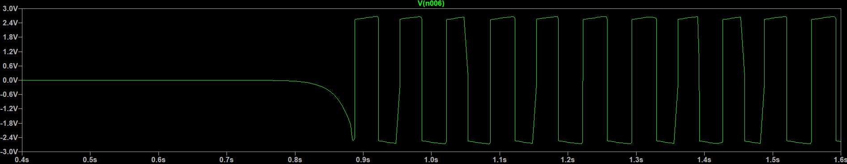

Fig. 3.2.1

2. Triangle wave: The function generator generates a signal that oscillates linearly between a high and low point. The triangular waveform is often used in testing amplifiers.[2]

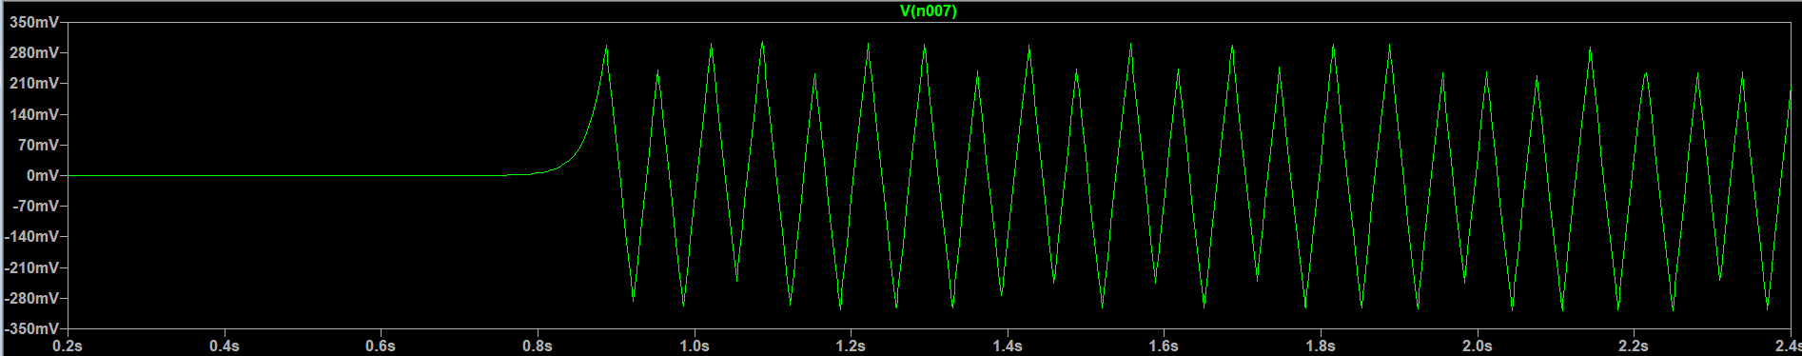Fig 3.2.2

3. Sine wave: A sine wave is a geometric waveform defined by the function y = sin x that oscillates, or moves periodically up, down, or side to side. It is basically a smooth, s-shaped wave that oscillates both above and below zero. Sine waves are used to help determine oscillator-related patterns.[3]

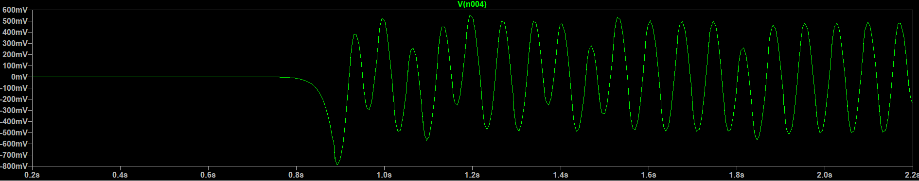

Fig 3.2.3

4. All the Output Waveforms together: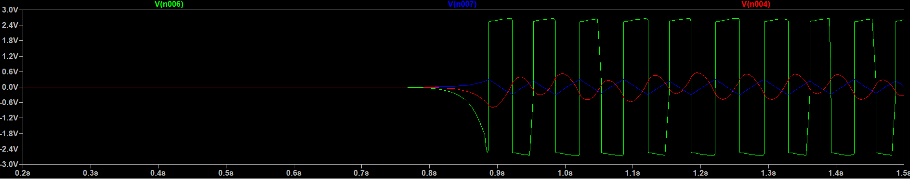

Fig 3.2.4

**CHAPTER FOUR**

Specifications taken from the Data sheet of UA741CP(prepared by Texas Instruments) [6]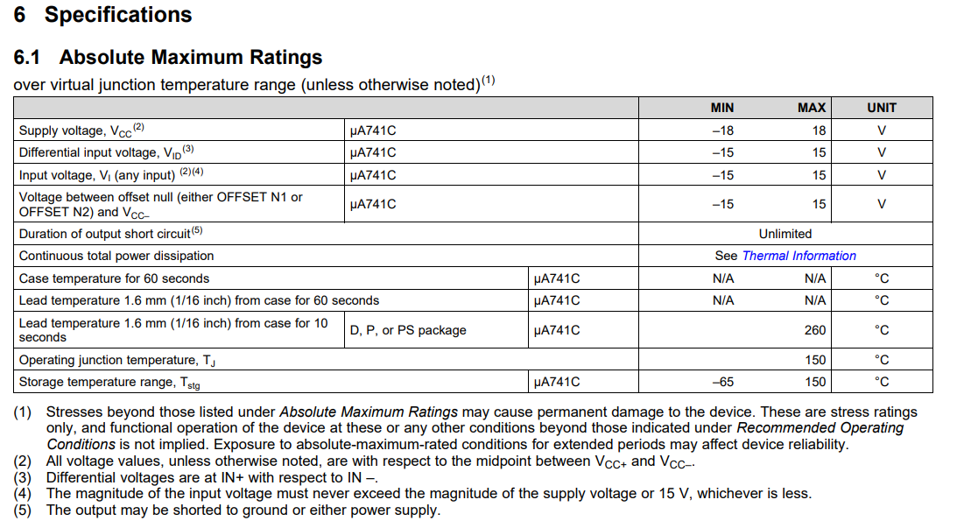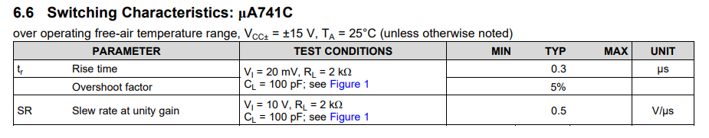

Table-1

Table-2

Table-3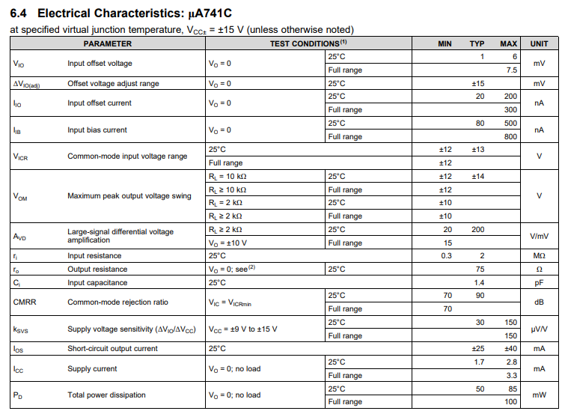

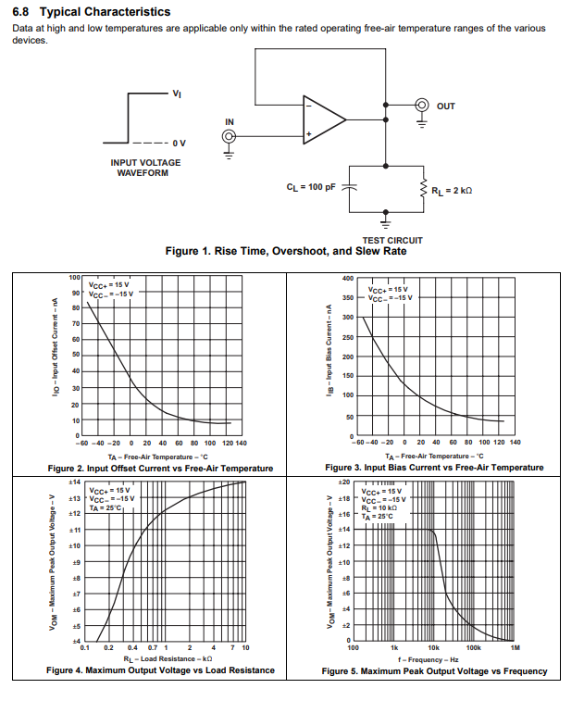

Table-4

List Of Other Components Used

* Three units of UA741CP IC
* Two units of 100k resistors
* Three units of 330k resistors
* Two units of 22k resistors
* Three units of 47k resistors
* One unit of 220k resistor
* One unit of 1uF capacitor
* One unit 0.47uF capacitor
* Three units of 0.1uF capacitors
* One unit of 9V battery
* Breadboard
* Jumper cables
* Multimeter

**CHAPTER FIVE**

Conclusion and Scope for Future Work

In conclusion, we have gained substantial new knowledge about electronic function generation, circuit design, and simulation, through the implementation of Function Generators using Operational Amplifiers(op amps). We have effectively shown throughout this project that it is possible to build waveforms by utilising the features of operational amplifiers.

Looking ahead, there are many areas for further refinement and enhancement of our function generator design, including the integration of additional features such as arbitrary waveform generation, frequency and amplitude modulation and many others. Additionally, exploring alternative circuit designs and components could lead to improvements in performance, efficiency, and scalability.

In summary, the development of the op amp-based function generator has been a significant milestone in our learning curve in the domain of electronic circuit design and signal generation. By combining theoretical insights with practical experimentation from within our syllabus itself, we have successfully created a versatile and reliable tool that can find applications in education, research, and industry

References:

[1]. Function Generators Explained:<https://www.electronics-notes.com/articles/test-methods/signal-generators/function-generator.php>

[2] Sine Wave: Definition, What It's Used For, Example, and Causes:<https://www.investopedia.com/terms/s/sinewave.asp>

[3] Understanding Function Generators:<https://www.electricity-magnetism.org/function-generators/>

[4] Function generator using operational amplifier (sine, triangular & square wave): https://ae-iitr.vlabs.ac.in/exp/function-generator/

[5] Ramakant A. Gayakwad, Op - Amps and Linear integrated Circuits, 4th ed., Prentice Hall, 2002.

[6] UA741 General-Purpose Operational-Amplifiers - Texas Instruments,<https://www.ti.com/lit/ds/symlink/ua741.pdf>